Simulation and Synthesis results:

1)Router Top module

pktm_gen_5;

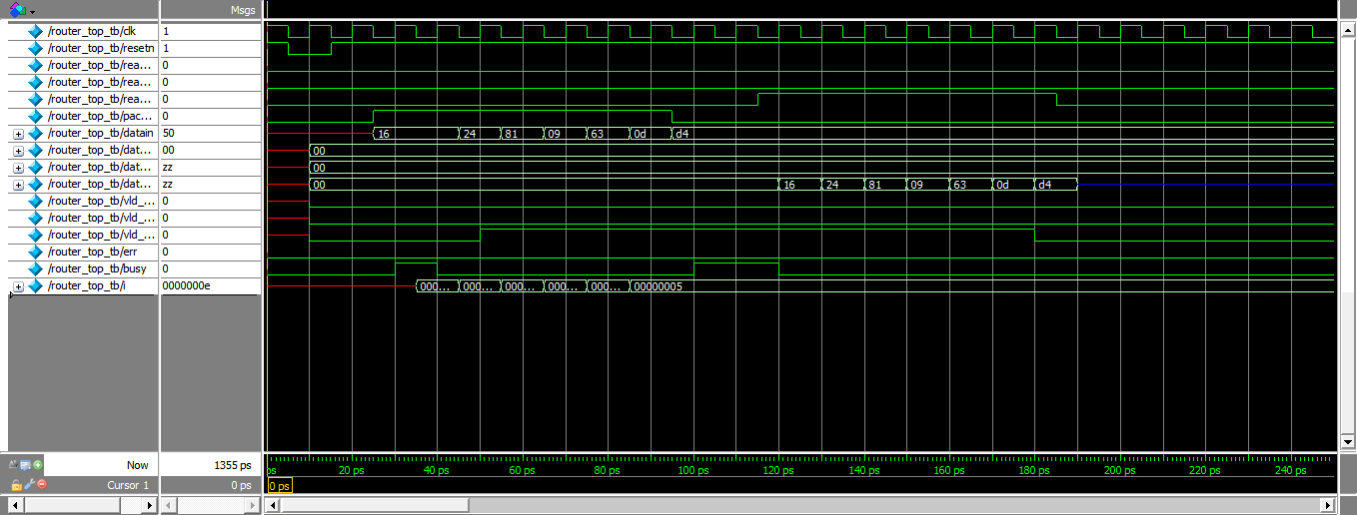

pktm_gen_16;

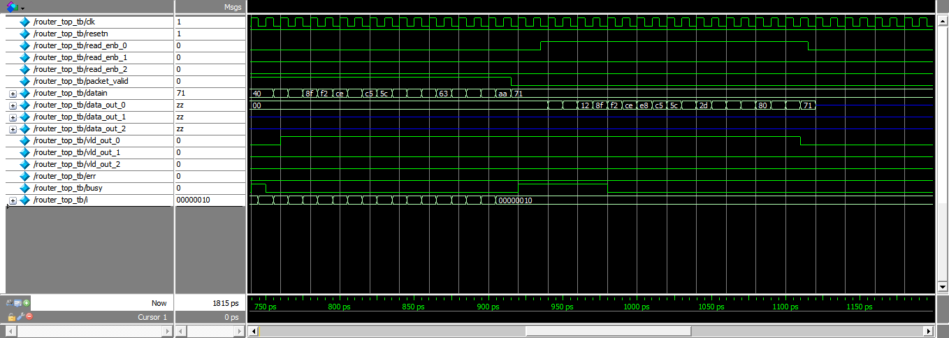

pktm_gen_14;

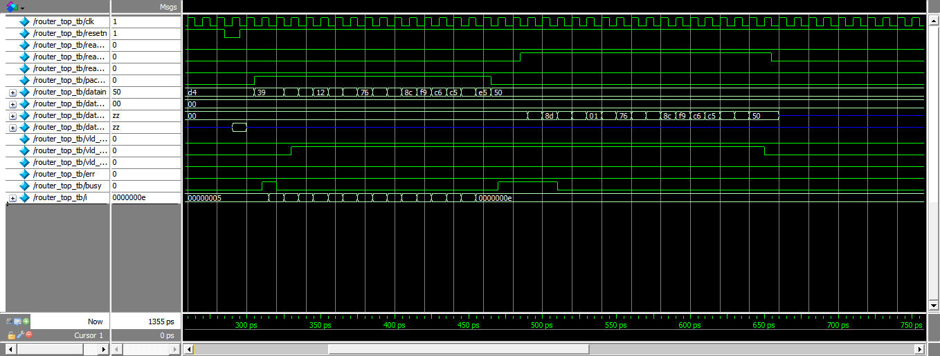

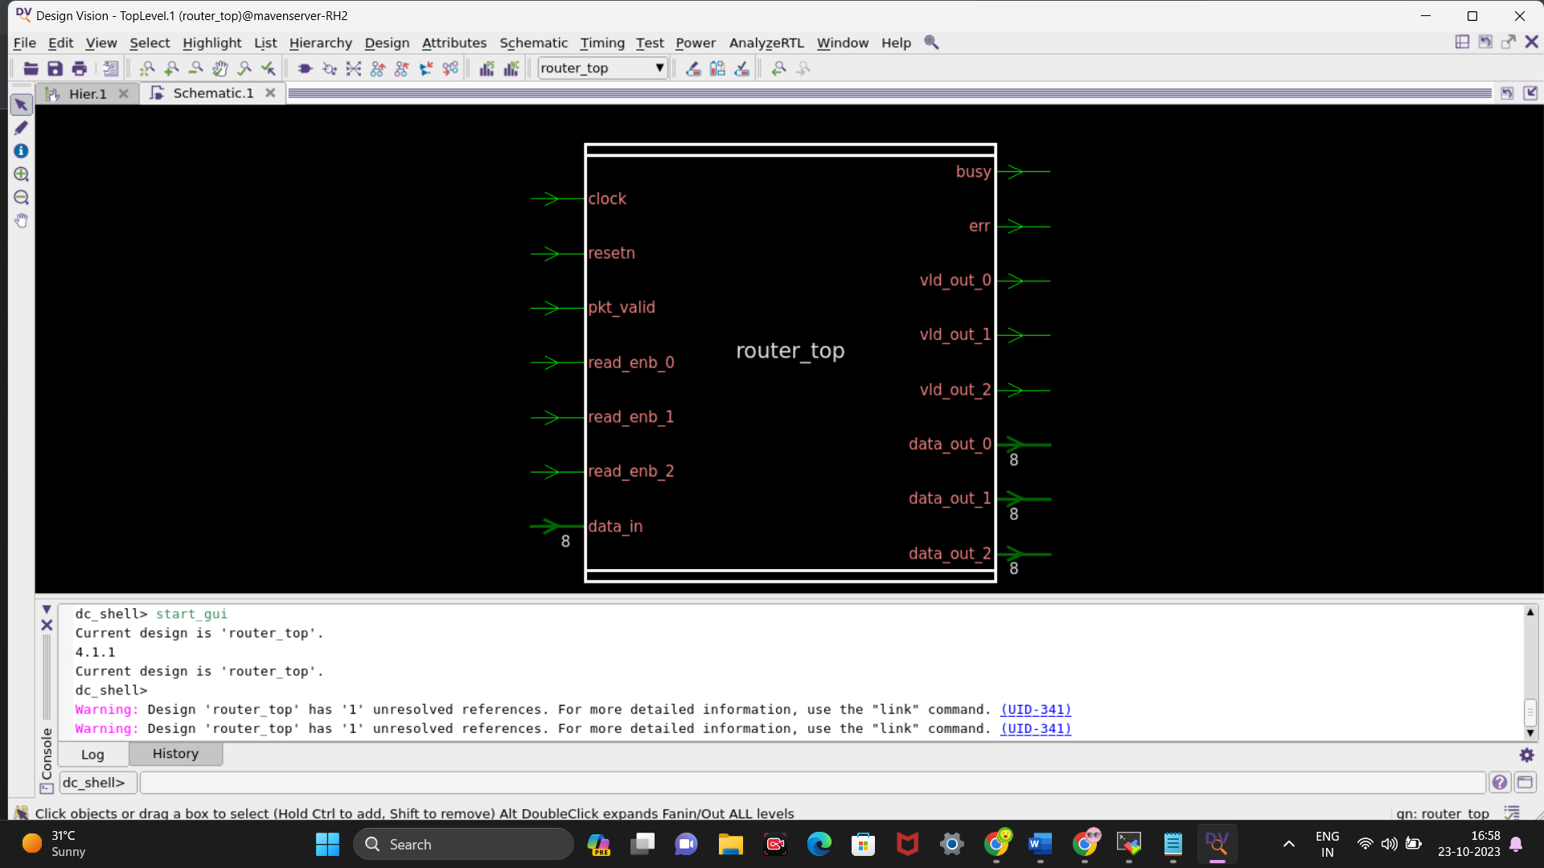

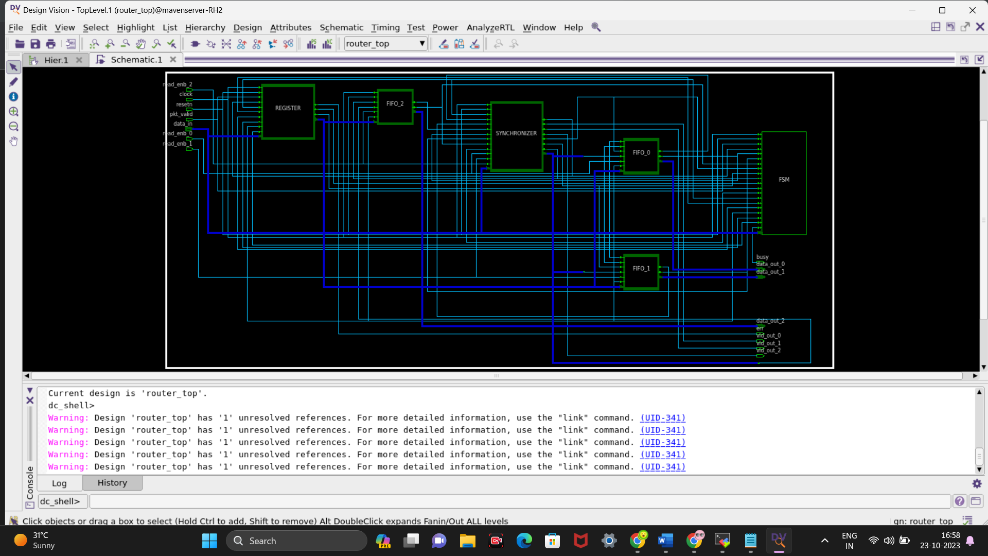

2)Synchroniser module

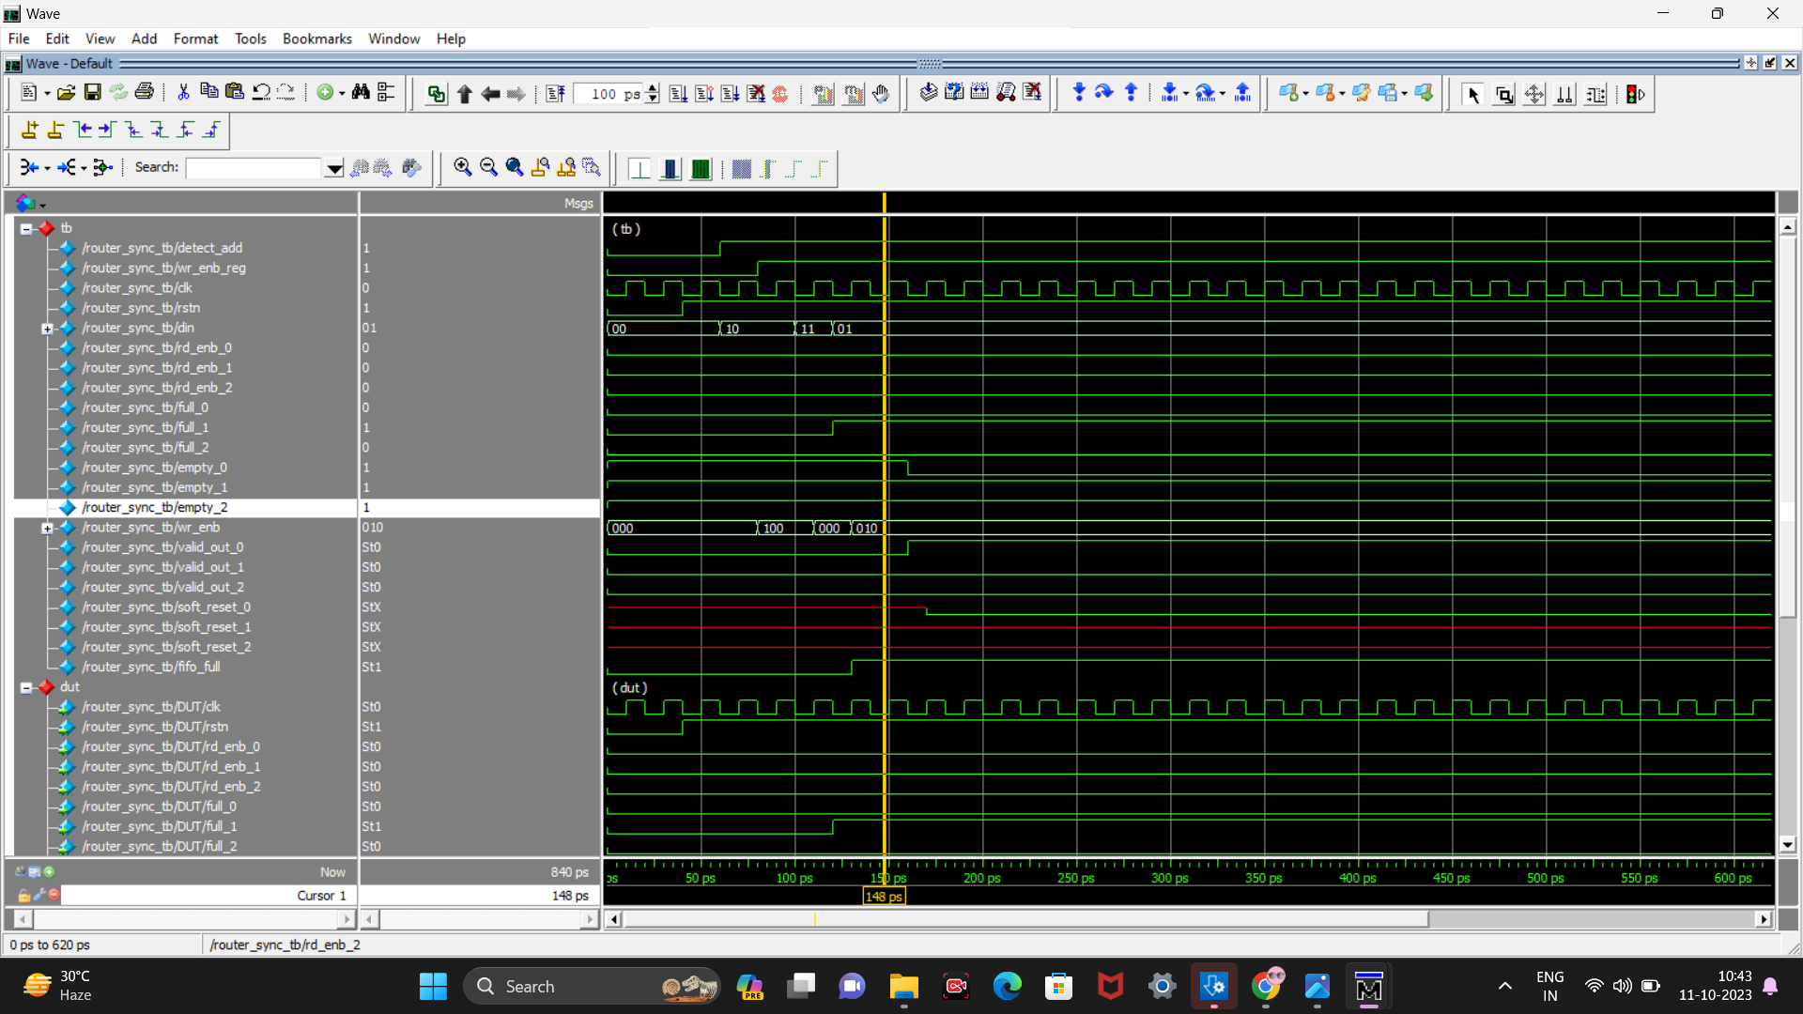

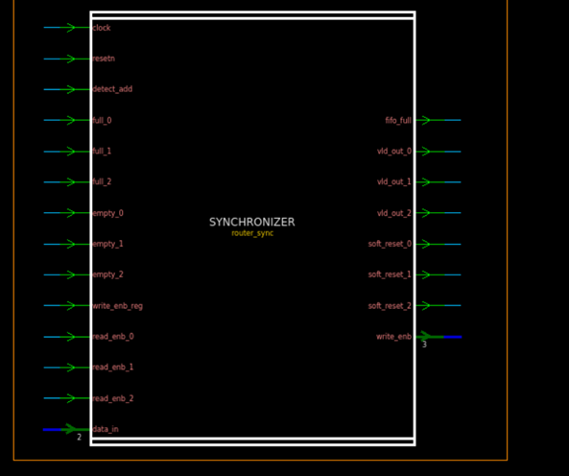

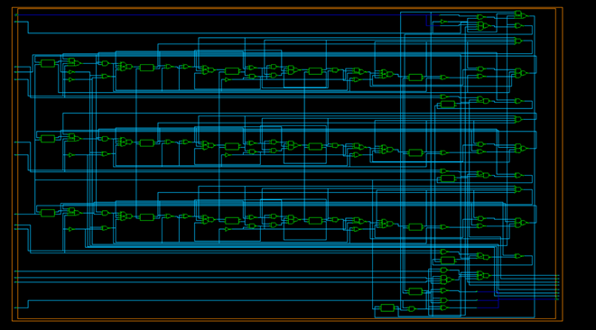

3)fifo module

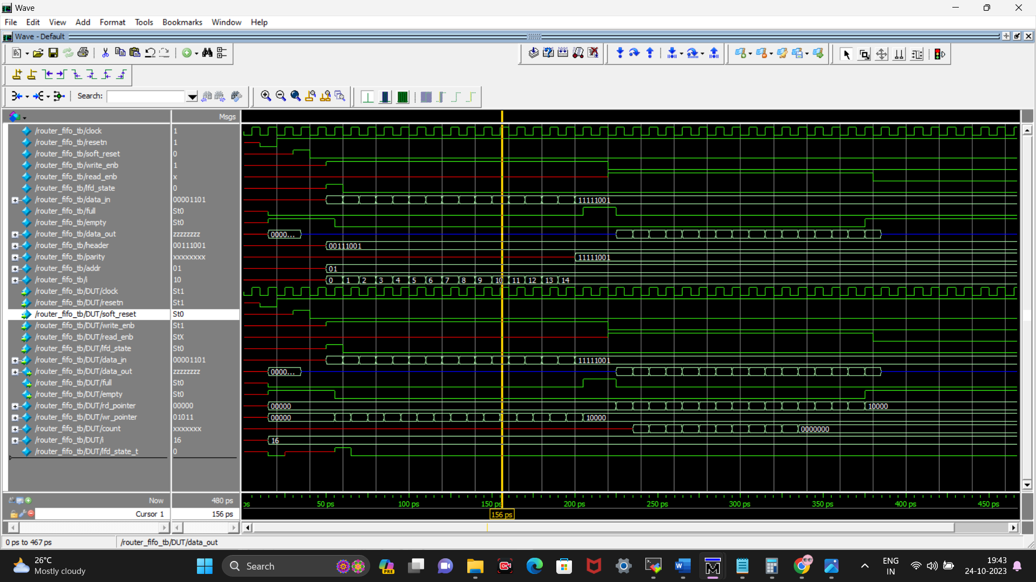

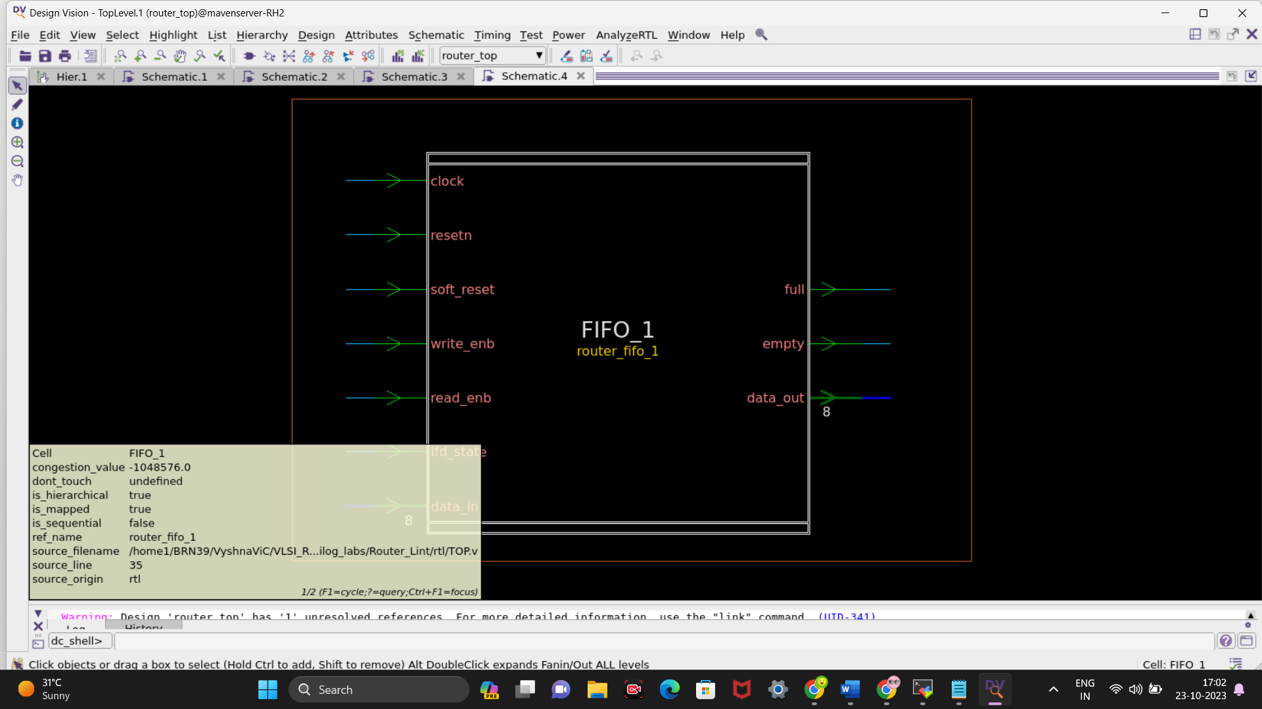

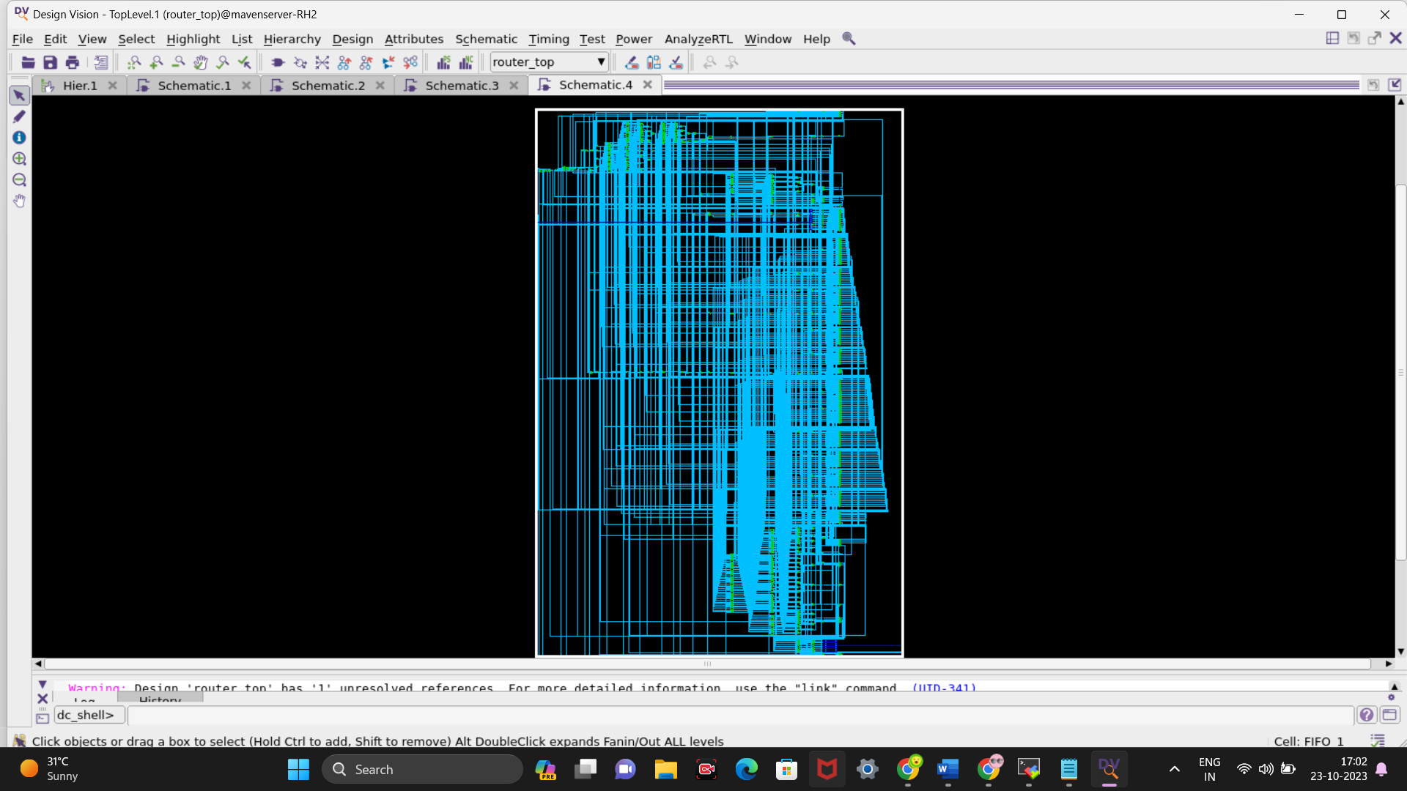

4)FSM module

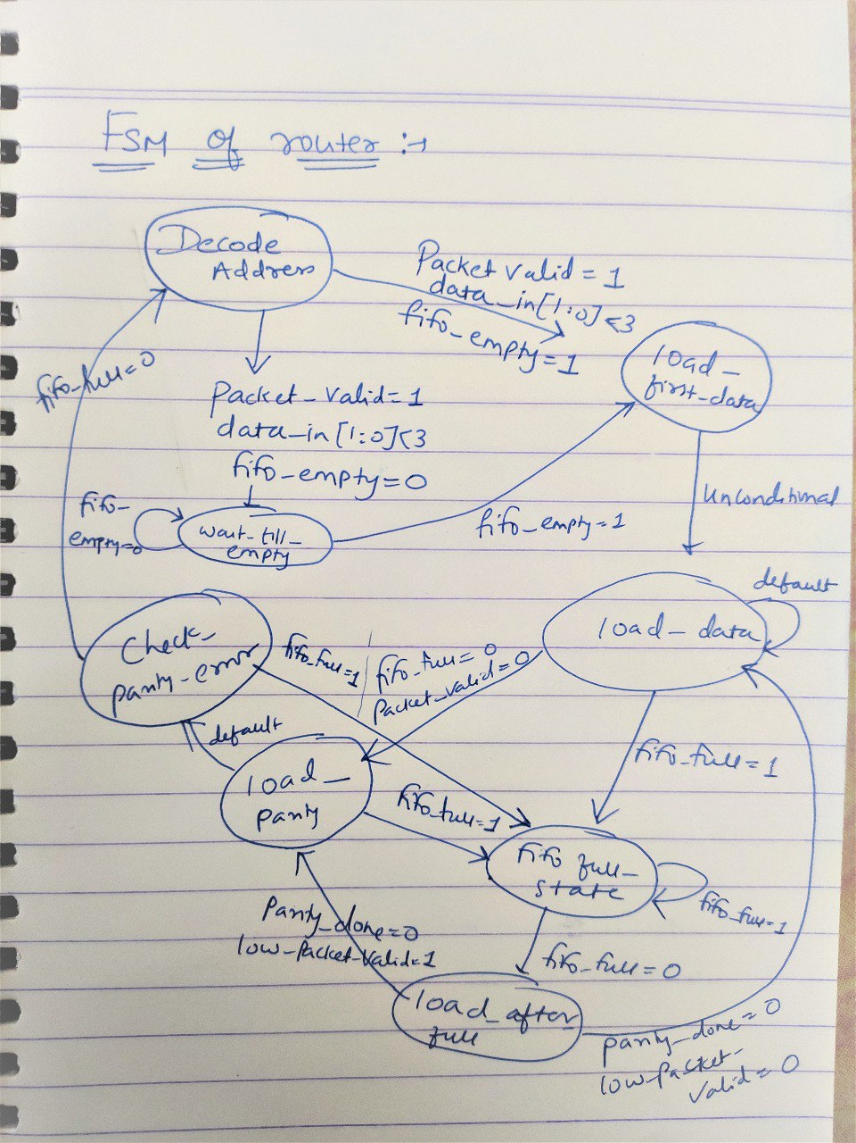

DA_LFD_LD_LP_CPE_DA; //000, 010, 011, 100, 111, 000 (0,2,3,4,7,0)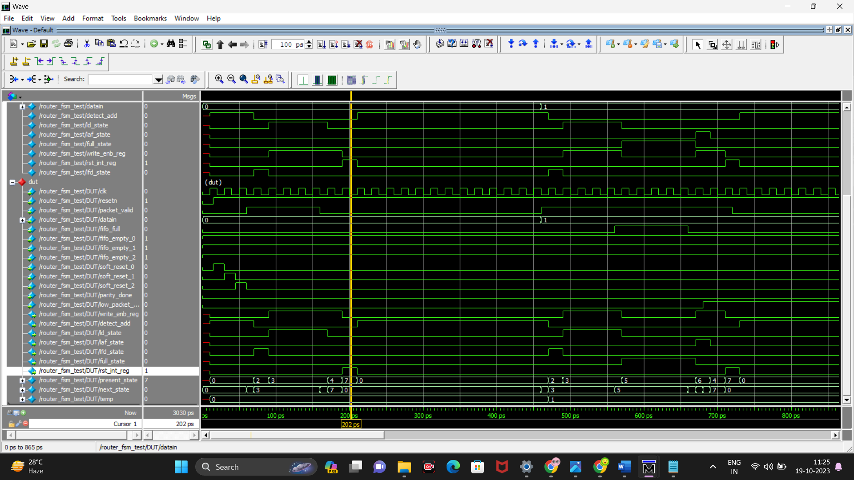

DA_LFD_LD_FES_LP_CPE_DA(); // 000, 010, 011, 101, 100, 111, 000(0,2,3,5,6,4,7,0)

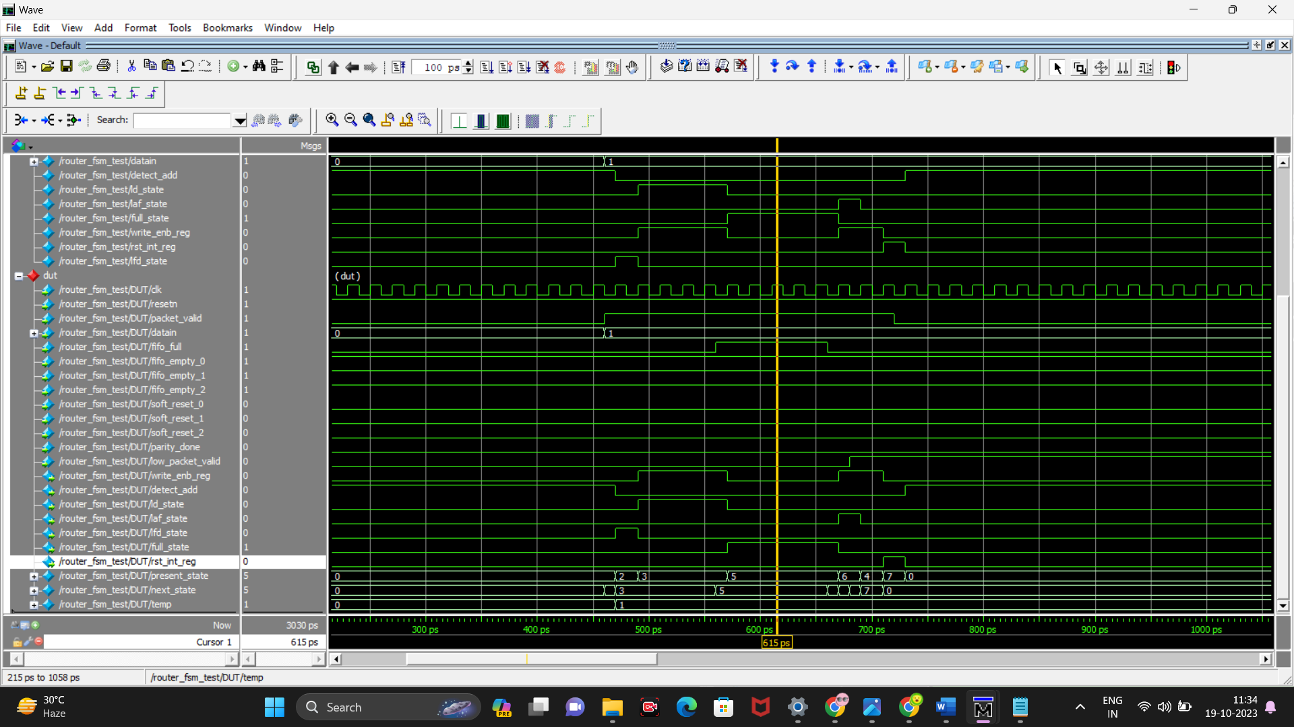

DA_LFD_LD_FES_LAF_LD_LP_CPE_DA; // 0,2,3,5,6,3,4,7,0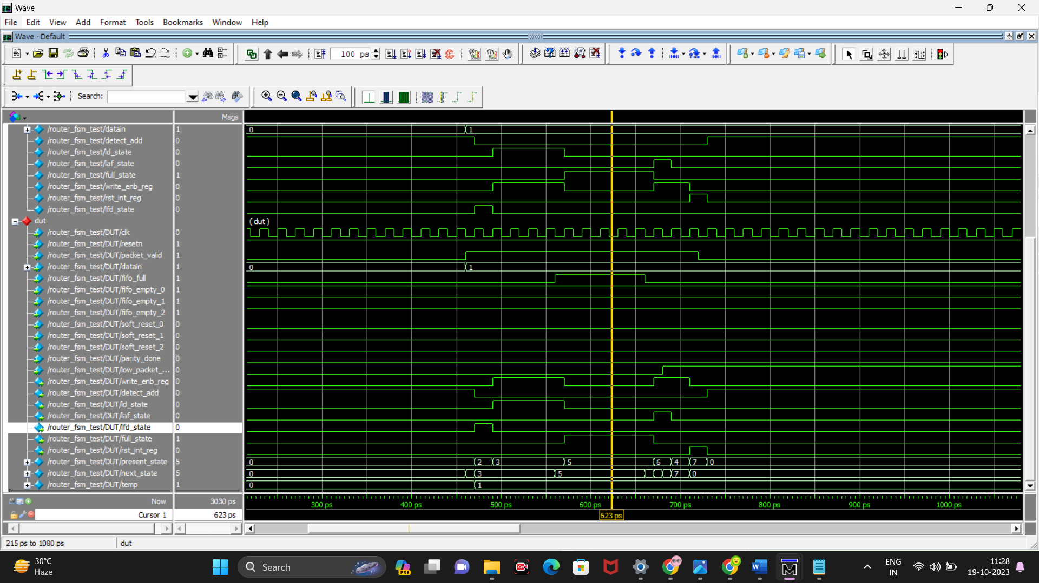

DA_LFD_LD_LP_CPE_FES_LAF_DA; // 0,2,3,4,7,5,6,0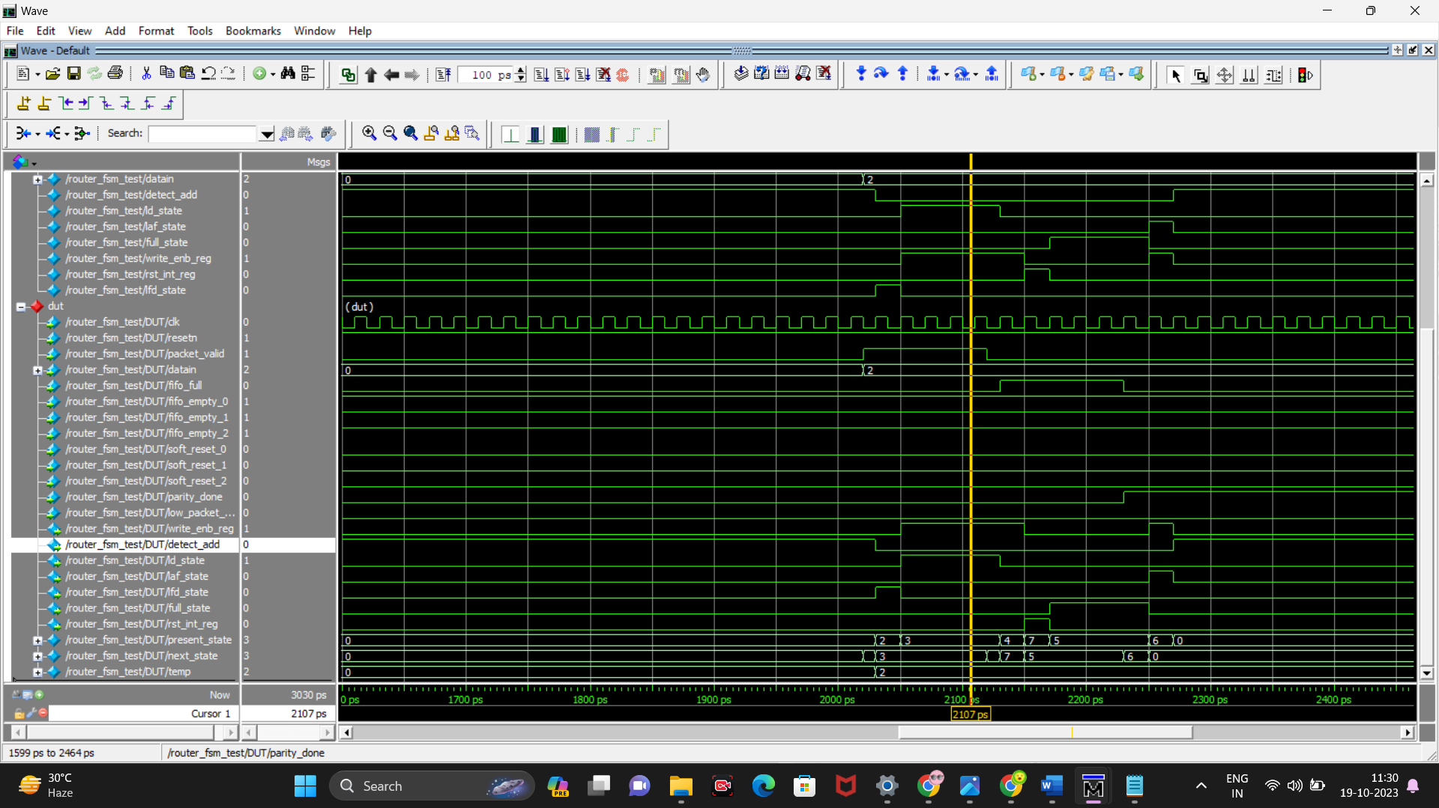

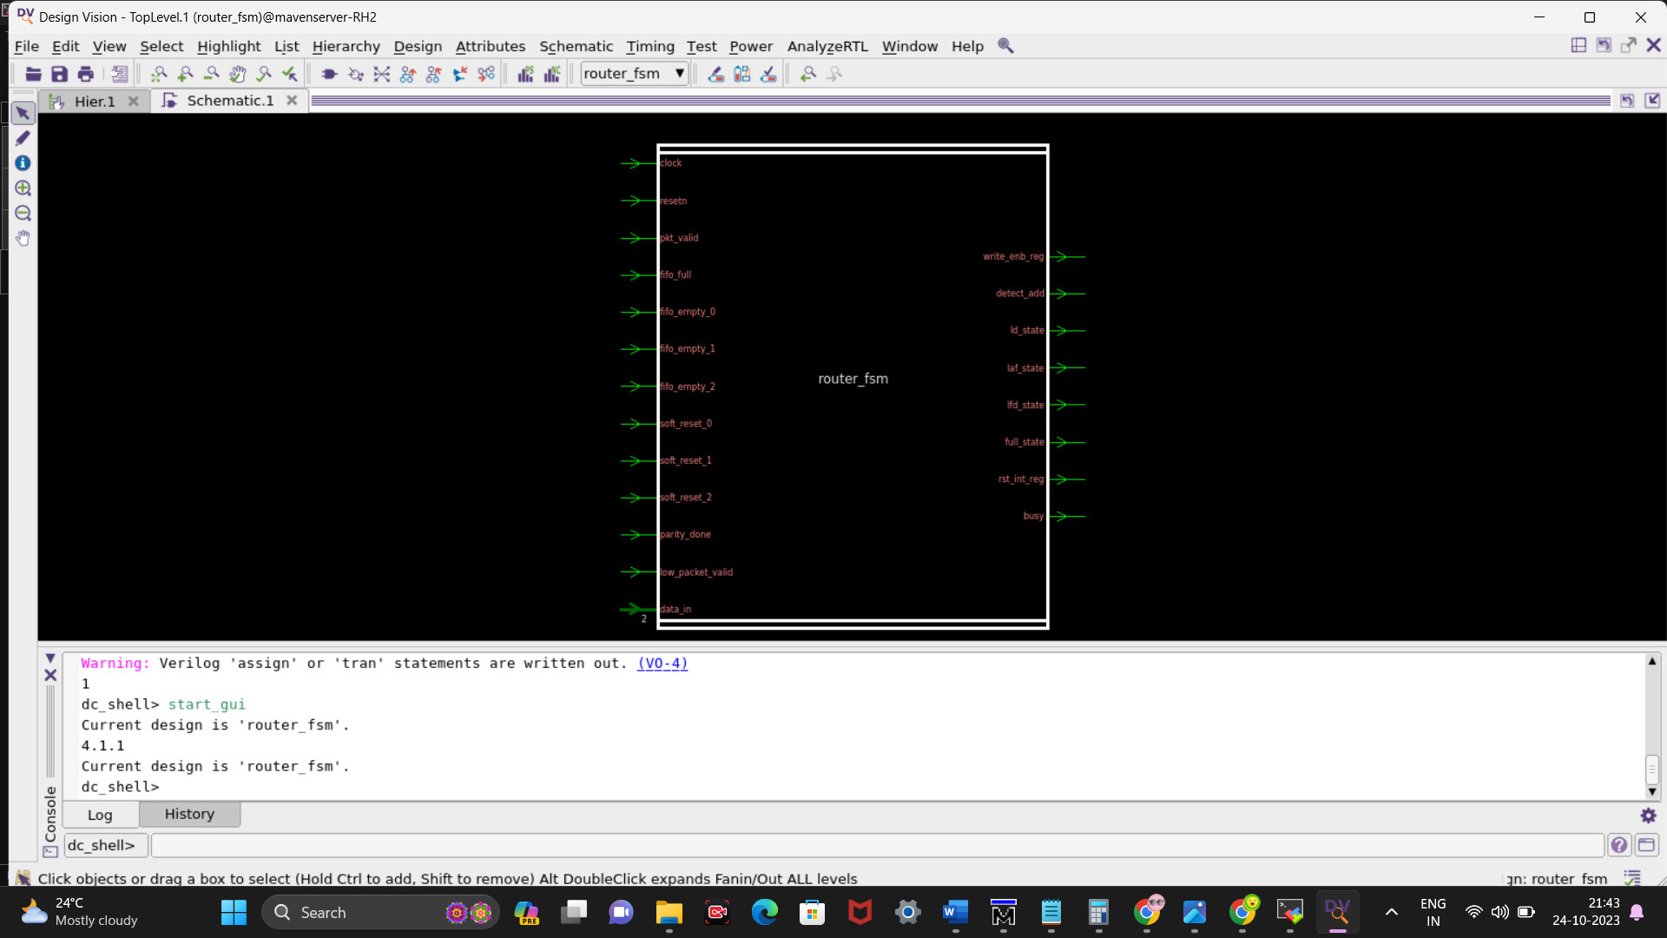

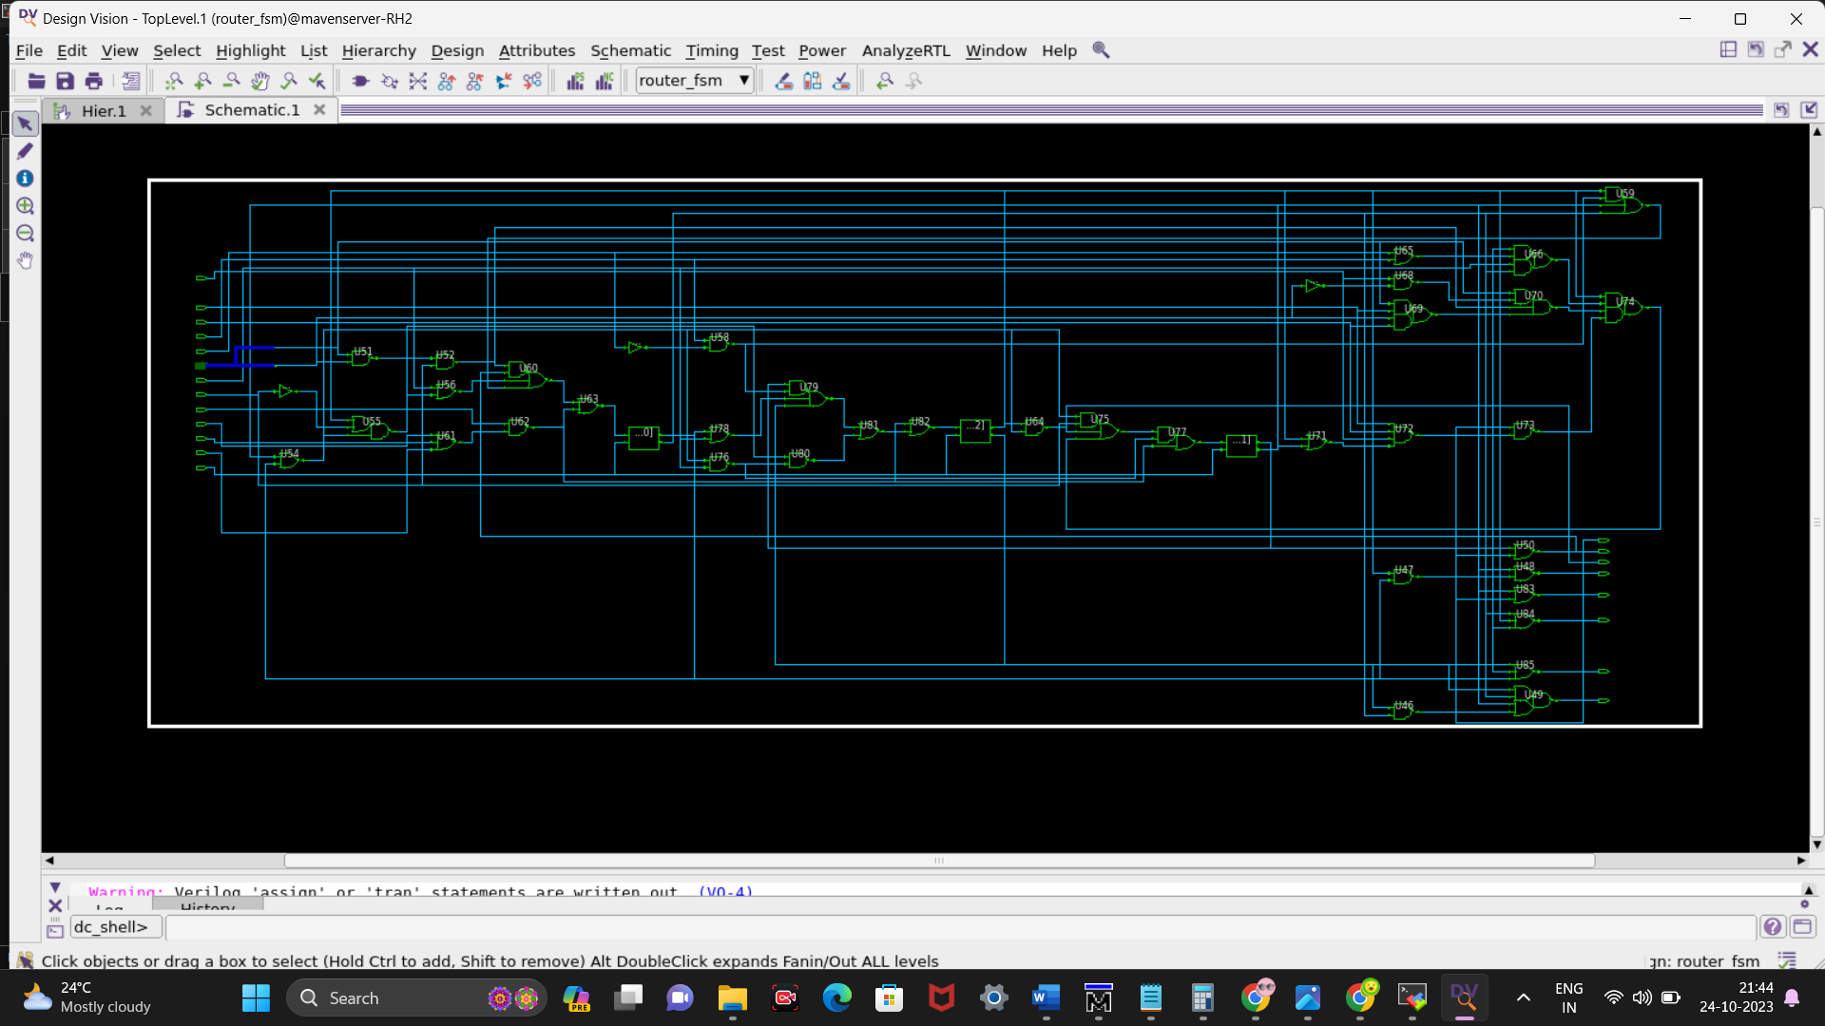

5) register module

